TASK 1

Aircraft Model | 𝐶𝐹 | ∆𝐹 | 𝐶𝑇 | ∆𝑇 | 𝐶𝑐 | ∆𝐹 𝑎 | ∆𝑇 𝑎 | cost | Code revised
PolyU-A380 | 1 | 1 | 2 | 5 | 10 | 0.2 | 0.2 | 834.468181006535 | 835.26
PolyU-A381 | 1 | 1.5 | 3 | 5 | 10 | 0.3 | 0.4 | 1053.309847460627 | 105.90
PolyU-A382 | 1 | 2.0 | 4 | 5 | 10 | 0.4 | 0.5 | 1272.0515139147199 | 1277.15
PolyU-A383 | 1 | 2.5 | 5 | 5 | 10 | 0.5 | 0.1 | 1490.2931803688125 | 1496.69

PolyU-A380 is the cheapest.
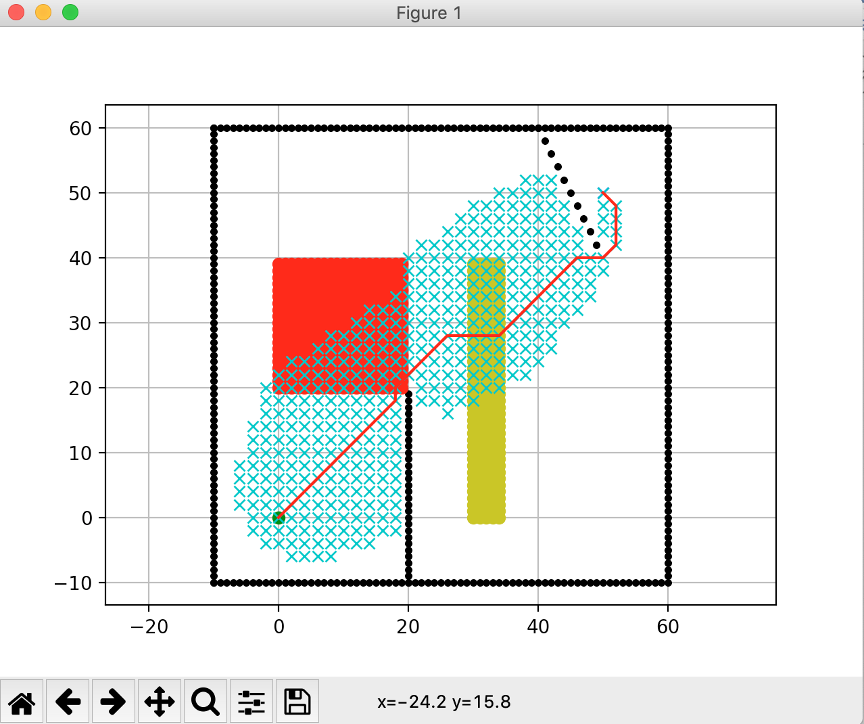

TASK 2
Aircraft Model | 𝐶𝐹 | ∆𝐹 | 𝐶𝑇 | ∆𝑇 | 𝐶𝑐 | ∆𝐹 𝑎 | ∆𝑇 𝑎 | cost
G9 | 15 | 1 | 1 | 10 | 10 | 1 | 9 | 1401

